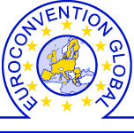
FREE PASS
Tajikistan Economic and Investment Forum 2014

Dates: 15 October 2014

Venue: National Library of the Republic of Tajikistan

PLEASE FILL IN THE FORM, SAVE IT AND SEND IT TO US BY RETURN.

Participant’s Details

First & Last Name:
Organization:
Position:
Organization Address:
ZIP + City + Country:
E-mail:
Phone:
Mobile:
I hereby confirm my participation to the Tajikistan Economic and Investment Forum 2014.
Participant signature:____________________
IMPORTANT NOTICE
Delegates are responsible for the arrangement and payment of their own travel and accommodation. This complementary pass is valid for one person only. Please RSVP ASAP as seats are allocated on a first come first served basis. For further information, we welcome your call at +32 2 662 16 12 or email to info@euroconventionglobal.com.

